# COMP201: Software Engineering I

## Task 1

Noun identification:

Nouns found:

* Customer
* Travel agency
* Reservation system
* Internet
* Travel reservations
* Travel insurance
* Primary client
* Multiple reservations
* Travellers involved
* Passport numbers
* Flight number
* Class of seat
* Travel dates
* Times
* Unique reservation
* Hotel reservations
* Type
* Name
* Address of hotel
* Car
* Car rental reservations
* Airlines
* Airline
* Hotels reservations
* Rental cars
* Client
* Address
* Dangerous sports
* High value items
* Drivers’ licence number
* Medical statement conditions
* Medical statements declaration
* Class of car requested
* Insurance booking

*Your customer is a travel agency that wants a reservation system that will run on the Internet. This reservation system will allow clients to keep track of all their travel reservations for airlines, hotel, travel insurance and rental cars. The client must enter the names of all his/her traveling companions, but all reservations will be under the name of the primary client. The system needs to make it easy for a client to have multiple reservations. All reservations will include a booking number as well as their names, passport numbers and dates of birth of all the travellers involved in the reservation. The system should also have an address for the primary client.*

*Airline reservations will include the airline, flight number, class of seat and travel dates and times. For each flight per passenger there will be a unique reservation.*

*Hotel reservations will include the type (twin, single, double) and of rooms and the dates staying. and name and address of the hotel.*

*Car rental reservations will include the class of car requested, dates and the drivers’ license number of the primary client.*

*For the insurance booking, this will include the maximum claim level for the policy and inclusions for dangerous sports (yes or no), high value items (yes or no), pre-existing medical statement conditions (yes or no) as well as optional medical statement declaration.*

**Identify classes:**

* Airline
* Insurance
* Client
* Car rental
* Hotel Reservation
* Reservation System
* Travel insurance
* Passenger

**Identify attributes:**

|  |  |  |  |  |  |  |
| --- | --- | --- | --- | --- | --- | --- |
| Airline | Client | Car Rental | Hotel Reservation | Reservation System | Travel Insurance | Passenger |
| Airline name | Name | Class of car requested | Type | Booking number | Dangerous sports | Passport number |
| Flight number | Travelling companion names | Date | Room | Primary clients | high value items | Name |
| Class of seat | Passport number | Drivers’ license number | Date |  | Medical statement conditions |  |
| Travel dates | Passengers |  | Address |  | Medical statement declaration |  |
| Time | Driving license number |  | Name |  |  |  |
|  | Address |  |  |  |  |  |

**Identify inheritance relationships:**

I can see from my UML diagram that the organisation that takes the clients handles the car rental, airlines, hotel and travel insurance. I see the relationship that they could ‘use’ those classes or implement them. I chose to use them because I wasn’t implementing the actual airline into the system. Just using the data. The reservation also uses the data from the client. Therefore, the booking system would ‘use’ the client. The other class, passenger, is part of the client - which is why the client would also take data from the passenger and pass it to the reservation system. Consequently, the client would have a ‘use’ relationship to the passenger. I was tempted for the insurance system to inherit from an insurance company or flights inheriting information from an airport or air company. This wasn’t necessary as there is not enough data to do this.

**Final UML class diagram**

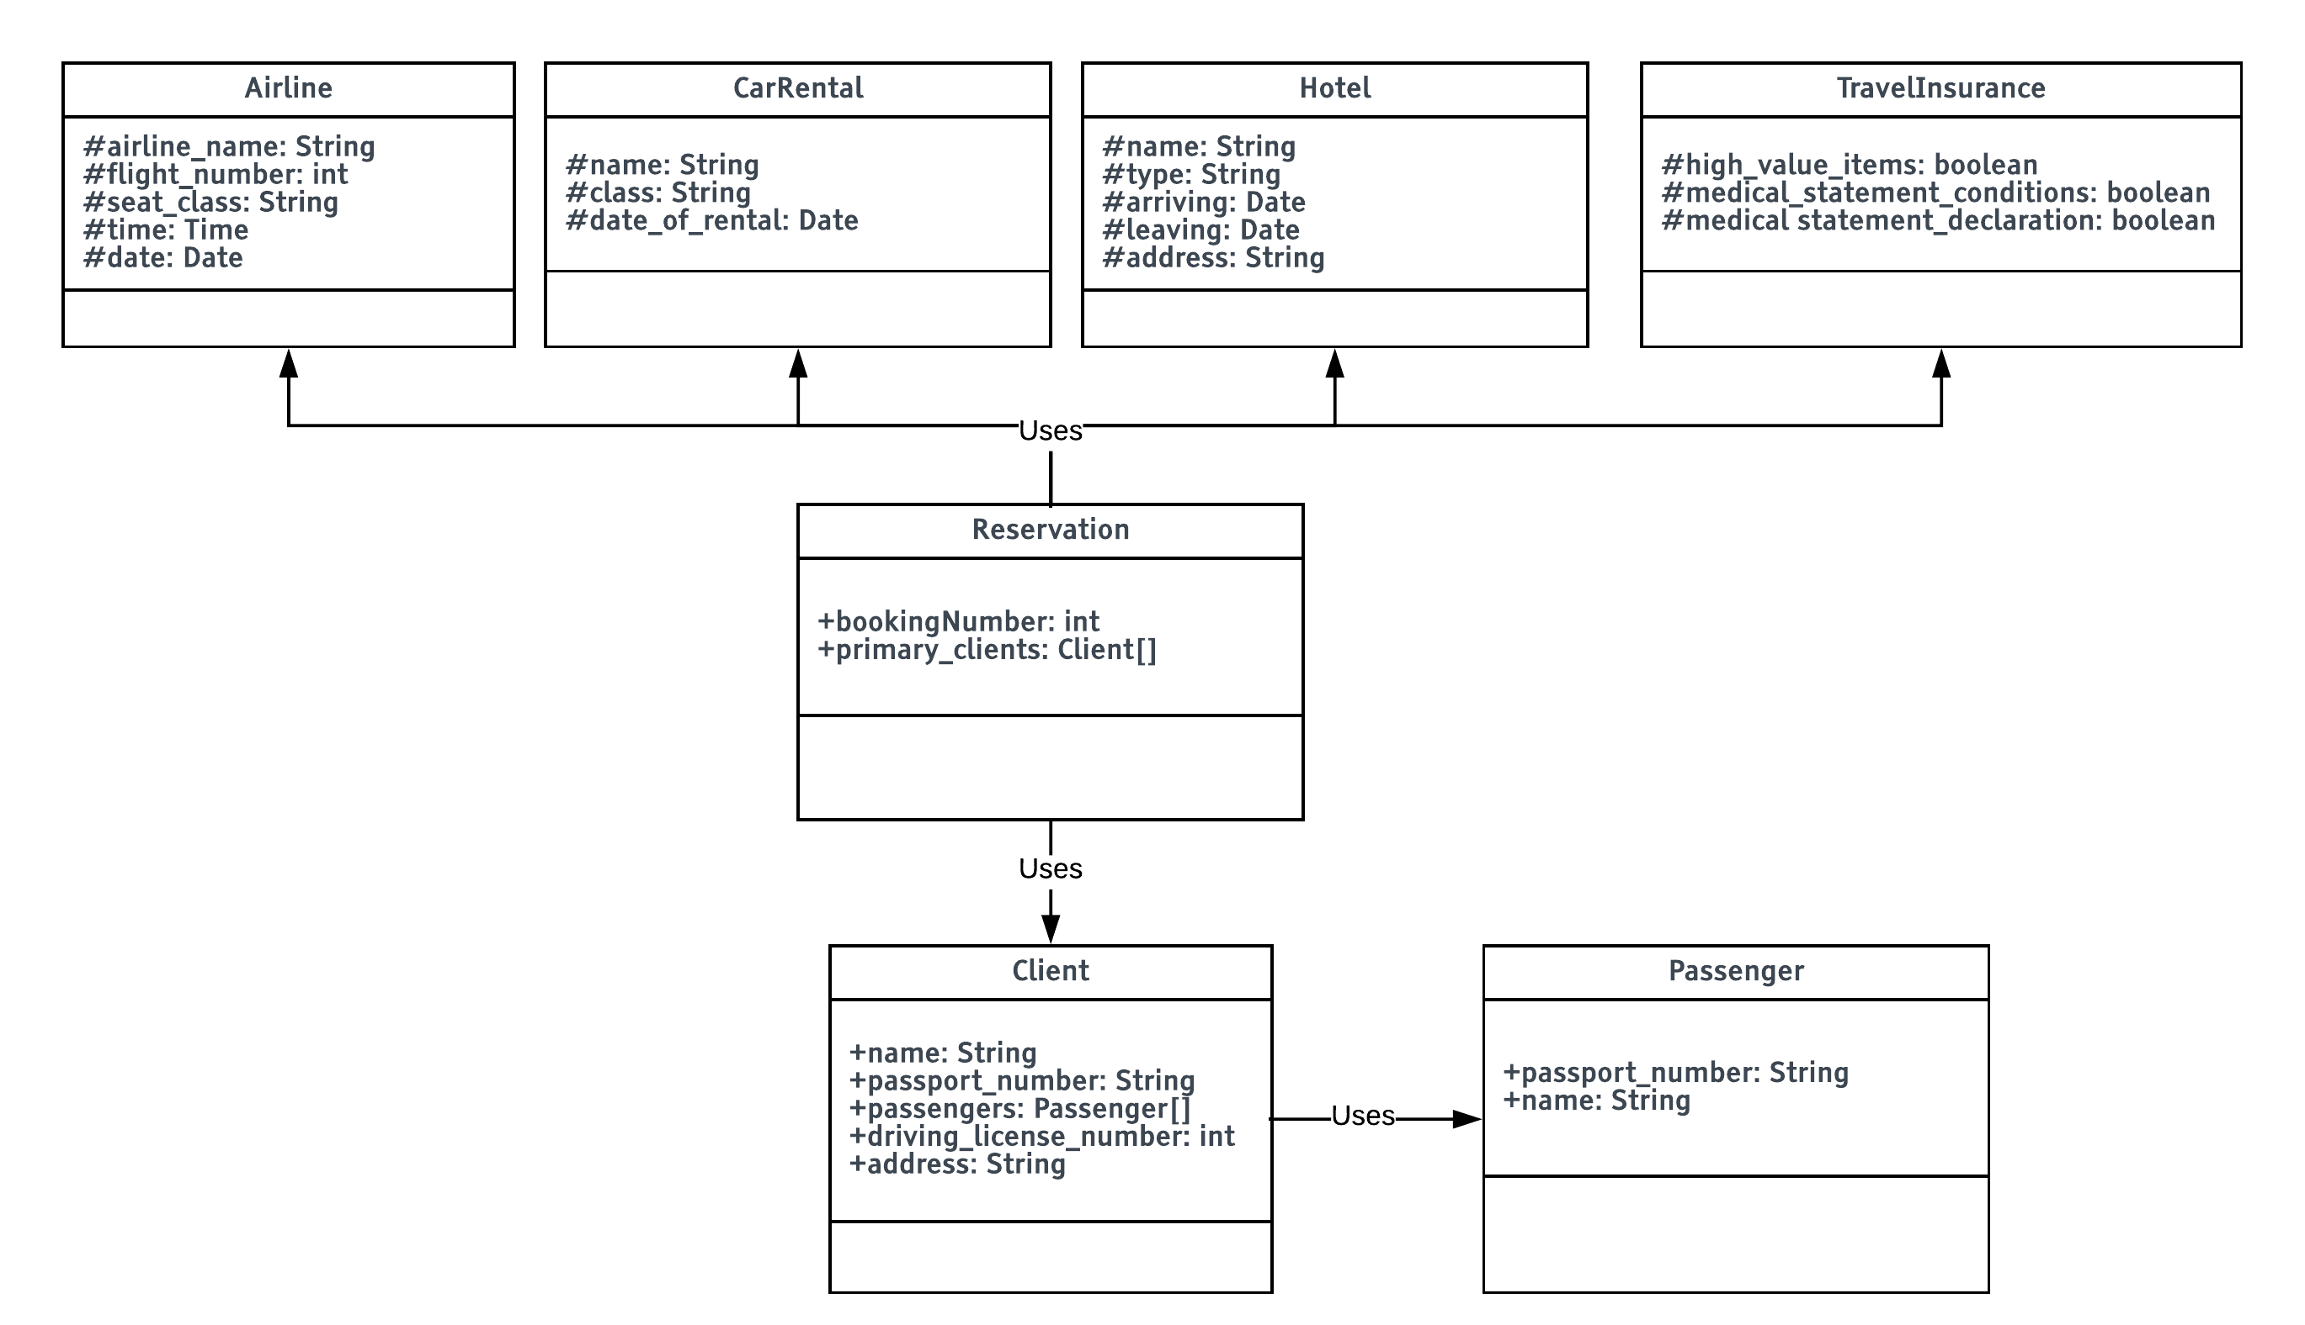

## Task 2

I will be modelling this in UML Activity Diagram based on the information I have learnt in lecture 21. From the question I have gathered these important facts:

1. The customer enters the salon

2. The customer waits for a seat to be free

3. The customer chooses "Hair wash" or "dry-cut"

4. The hair dresser washes the hair

5. If customer is done, next in queue is served or hairdresser waits for someone to enter

6. The customer goes to a cashier and gets in queue to pay - Cash and credit card only

7. The served customer leaves

From this, I can see the important features of the system to implement. I will include this into the UML diagram. Below is the UML activity diagram:

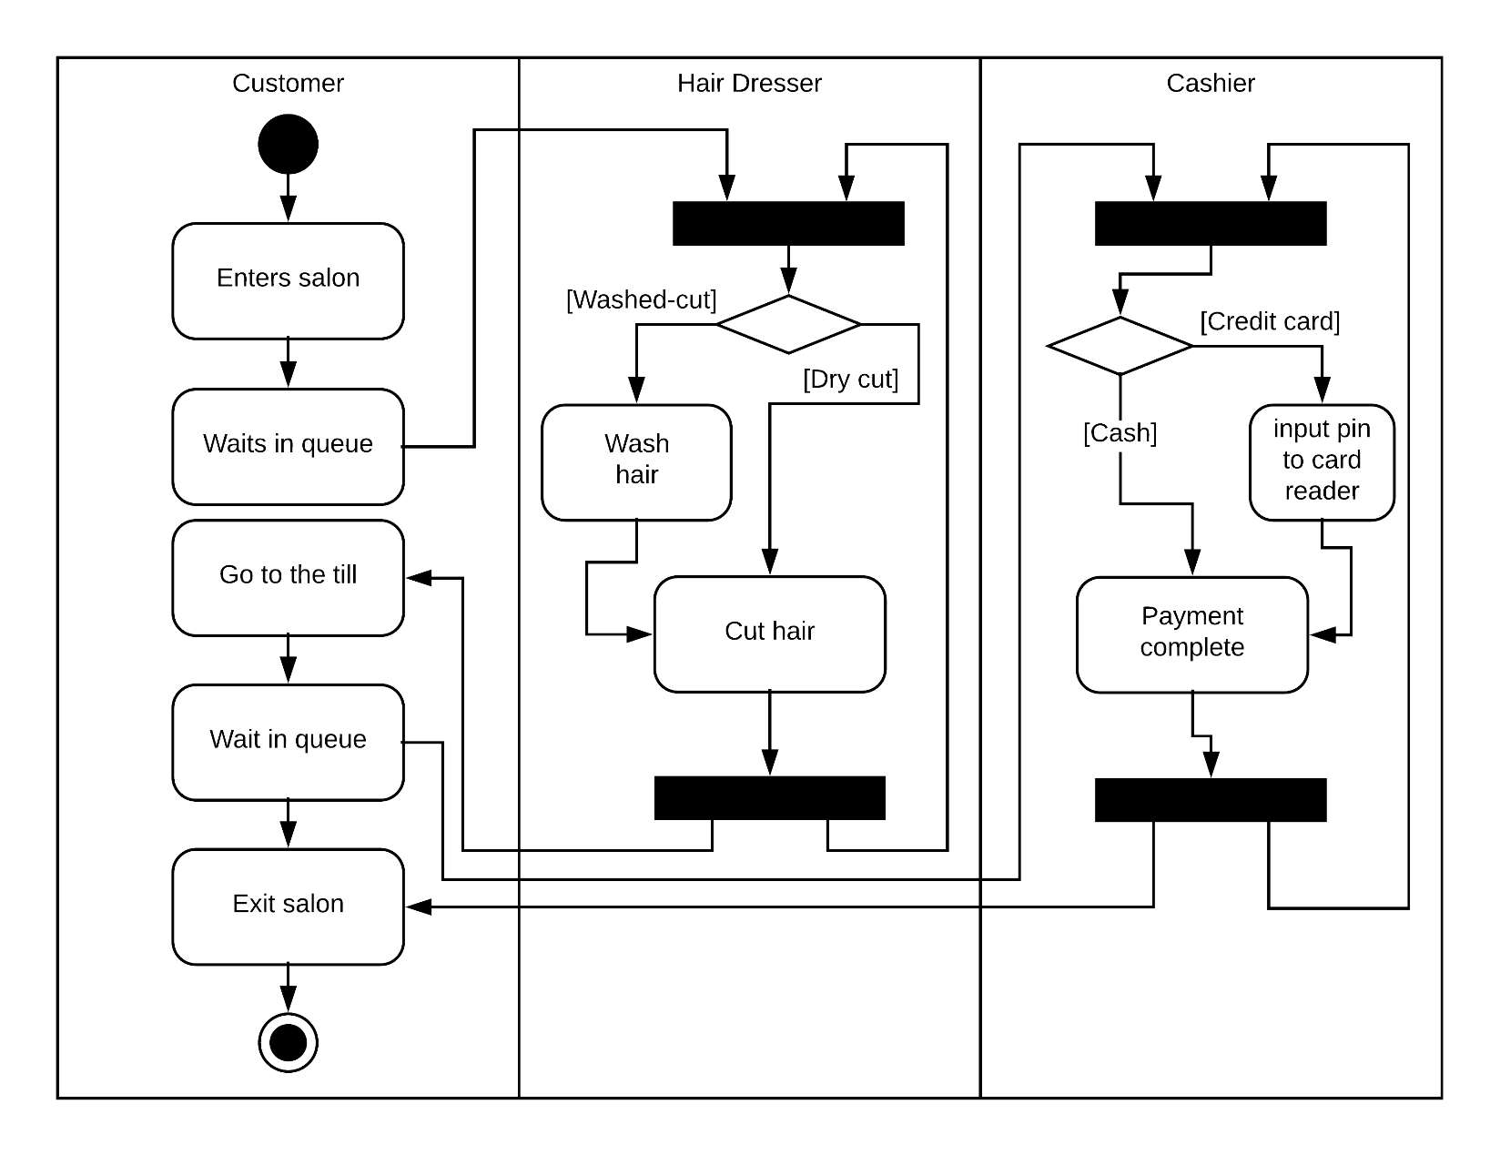

## Task 3

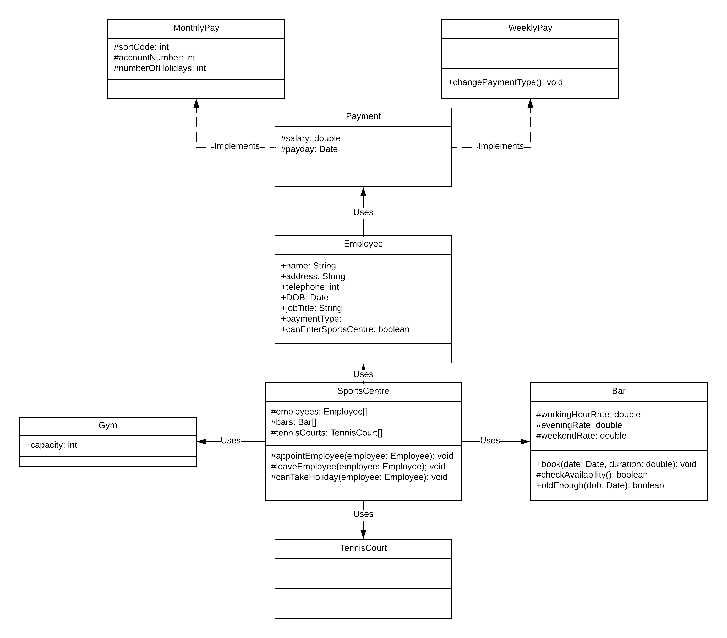

## Task 4

